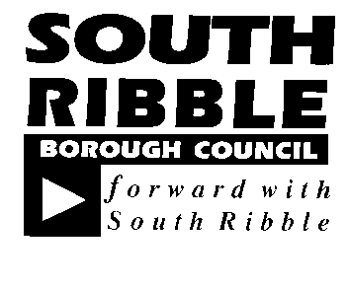  REPORT TO | ON
General Licensing Committee | 20 November 2018
TITLE |  | REPORT OF
Licensing Activity |  | Head of Licensing

Is this report confidential? | No

- PURPOSE OF THE REPORT

This report provides information to members on Licensing Activity, including applications received, enforcement checks and referrals to partner agencies

- CORPORATE PRIORITIES

The report relates to the following corporate priorities:

Excellence and Financial Sustainability | x
Health and Wellbeing

Place

Projects relating to People in the Corporate Plan:

People

- RECOMMENDATIONS

3.1 That Members note the progress made by the Licensing Service for the month of September and October 2018

4. BACKGROUND TO THE REPORT

4.1 Monthly updates on service delivery have been a regular item on the General Licensing Committee Agenda and include in table format the activity carried out by the Licensing Service

4.3 Areas of particular note for this period are the submission of 2 Licensing Reviews, to be determined for Moss Lane Convenience and Sangham Balti in the next couple of weeks.
Underage test purchasing relating to Gaming Machines, 7 premises tested, 7 failures, SRBC were the first Authority in Lancashire to conduct this type of testing which has led the Gambling Commission to work with other Lancashire Authorities where similar results have also played out. A full write up of the Commissions work with Local Authorities relating to the recent test purchasing will be in the January bulletin.
Launch of the Award for Personal Licence holder’s course, initially uptake is slow but we are now offering the course on a monthly basis. The course is advertised through social media and with partner agencies.
Pubwatch planning meeting was organised with National Pubwatch representatives in attendance to provide guidance and support in setting up a Borough wide Pubwatch. The meeting was well attended and well received, over 30 attendees expressed a commitment to moving the idea forward. A follow up planning meeting is scheduled for the 15th November to elect and Chair and vice Chair.
Alcohol test purchasing was conducted with the police on the 25th October, the volunteer was on the younger end of the spectrum for the activity (14years old). 111 premises were tested and only 1 failed. Due to the age of the volunteer and the fact that almost every other premises passed this really highlighted bad practice at the relevant premises. An investigation is ongoing, therefore no further details can be provided at this stage.

5. CONSULTATION CARRIED OUT AND OUTCOME OF CONSULTATION
N/A

6. Financial implications

6.1 There are no direct financial implications arising from this report.

7. LEGAL IMPLICATIONS

7.1 There are no direct legal implications arising from this report.

8. COMMENTS OF THE STATUTORY FINANCE OFFICER

9. COMMENTS OF THE MONITORING OFFICER

There are no legal implications identified.

10. OTHER IMPLICATIONS:

- HR & Organisational Development  - ICT / Technology  - Property & Asset Management  - Risk  - Equality & Diversity | None  None  None  We must continue to improve further the quality of the service. We must do everything possible to protect the general public. A failure to continue to achieve high standards in our Licensing service could result in reputational damage.  None

11. APPENDICES

Appendix A - Improvement Plan 2018/19

Report Author: | Telephone: | Date:
Mark Marshall | 01772 625401 | 5 November 2018

